

SMALL BUSINESS
MANAGEMENT TEAM
(510)

FINAL
NATIONAL 2020

TOTAL POINTS ___________ (170)

Judges: Please double check and verify all
scores and answer keys!

Property of Business Professionals of America.
May be reproduced only for use in the Business Professionals of America
Workplace Skills Assessment Program competition.

Description
The team will use strategic planning and problem-solving skills to provide solutions to the business case study provided. At State and National level, teams will be presented with an additional element to the scenario that requires revision of their final presentation.

Modification at National Final Competition:
Personnel costs are Mr. Jackson’s biggest expenses. Besides a regular wage, his salesman makes a 25% commission on all sales he is able to close. Last year, the salesman made $175,000 in sales out of the overall $300,000. In 2011, Mr. Jackson attempted to hire a second salesman. He experienced very marginal benefits and very small increases in sales, so he only kept the person on staff for one year. Would you recommend that Mr. Jackson make any changes to his staff? Should he add or remove any positions? How would these changes help his revenue?

Initial Case Study

Fred Jackson, owner of ABC Graphics, has noticed that his company has lost a significant amount of revenue over the past few years. Mr. Jackson opened his business in 2005 after graduating from a graphic design program. He is very knowledgeable in the tools used in the graphic design industry. At first, his company thrived and Mr. Jackson was the recipient of many local awards for his successful business. His success continued through 2008 where revenues plateaued and then starting in 2011 began to steadily decrease. This is depicted on the graph below.

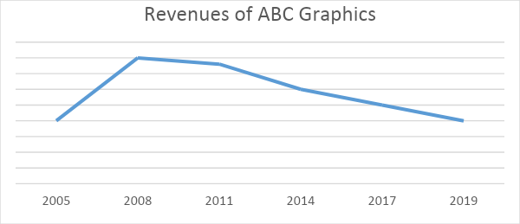

Mr. Jackson was concerned that the market had potentially become saturated and that all graphic design businesses were suffering. However, after doing some market research, there are newer companies opening, charging similar prices and are continuing to be successful. The research also showed that most organizations are still paying other companies to complete their graphic design work rather than completing it through their own employees.

ABC Graphics has on staff a salesman and an administrative assistant. Mr. Jackson completes all the graphic work himself. The salesman’s job is to find opportunities for Mr. Jackson to complete work for companies. The salesman then takes Mr. Jackson’s designs to the companies for their final approval and purchase. Mr. Jackson hired the salesman in 2008 when he noticed that sales began slowing down. The salesman has provided ample opportunity for graphics to be sold, but the final products are not being bought. Most potential clients prefer the design of a competing graphics company.

Prepare a presentation for Mr. Jackson with your suggestions for his company including, but not limited to, the questions below.

- What might be a reason that organizations are buying artwork/logos from other graphics companies and not ABC Graphics?
- What are some potential marketplace influences that could be affecting ABC Graphics’ revenue stream?
- What is the business lacking to meet the needs of an ever-changing market?
- What changes should the owner make to foster/develop future success?

Teams who do not submit an entry that follows this topic will be disqualified.

judging procedure
- Teams will be introduced by team number. However, contestants may continue to wear their name badges and refer to each other by name.
- As a team of judges, formulate two to three questions to ask at the conclusion of the presentation. Be sure to ask the same questions of each team.
- Teams will present before a panel of judges and timekeeper.
- All team members must participate.
- The length of set-up will be no more than three (3) minutes.
- The length of the presentation will be no more than ten (10) minutes; followed by judges’ questions not to exceed ten (10) minutes.
- Excuse teams upon completion of judges’ questions.
- There can be no ties in the top ten (10) teams. It is the responsibility of the judges to break any ties.
- Administrator will fill out ranking sheet prior to dismissing the judges.
- If more than one (1) section is necessary, finalists will be determined by selecting an equal number from each section.
- Give administrator all Judges’ Rating Sheets, Judge Evaluation Sheets, and contest materials.
- No audience will be allowed.

Please double-check and verify all scores!

